1. Kemtai (Most Related)
Website: https://kemtai.com/
Pricing: Paid (Subscription-based)
Platform: Web, Mobile
Target Users: Gyms, Rehabilitation Centers, Personal Trainers, Home Users
Summary
Kemtai is an AI-powered fitness platform that uses computer vision to analyze human movements through a standard camera. It automatically recognizes exercises, counts repetitions, evaluates exercise form, and provides real-time coaching without requiring wearable devices.
Key Features
- AI-based pose estimation
- Automatic exercise recognition
- Real-time repetition counting
- Form correction and posture analysis
- Performance scoring
- Works with standard webcams and smartphone cameras
- Suitable for gyms, rehabilitation, and home workouts
- No wearable devices required

2. VAY Sports
Website: https://vay-sports.com/
Pricing: Paid (Subscription-based)
Platform: Mobile (Android & iOS)
Target Users: Individual Users, Fitness Enthusiasts
Summary
VAY Sports is an AI-powered fitness application that monitors users during workouts using computer vision. It detects body movements, tracks exercise performance, and provides personalized coaching through a smartphone camera.
Key Features
- Motion tracking
- Exercise recognition
- AI-powered rep counting
- Voice-guided coaching
- Personalized workout feedback
- Progress tracking
- Smartphone camera only (no additional hardware)
- No wearable devices required

3. Peloton Guide
Website: https://www.onepeloton.com/guide
Pricing: Paid (Requires Peloton Guide device and membership)
Platform: Dedicated Hardware + TV
Target Users: Home Fitness Users
Summary
Peloton Guide is an AI-powered camera-based fitness system that recognizes exercises, counts repetitions, and tracks users' movements during workouts. It provides personalized insights and integrates with Peloton's interactive fitness ecosystem.
Key Features
- AI exercise recognition
- Automatic repetition counting
- Muscle engagement tracking
- Real-time movement monitoring
- Personalized workout recommendations
- Integration with Peloton classes
- Dedicated AI camera device
- Performance tracking dashboard
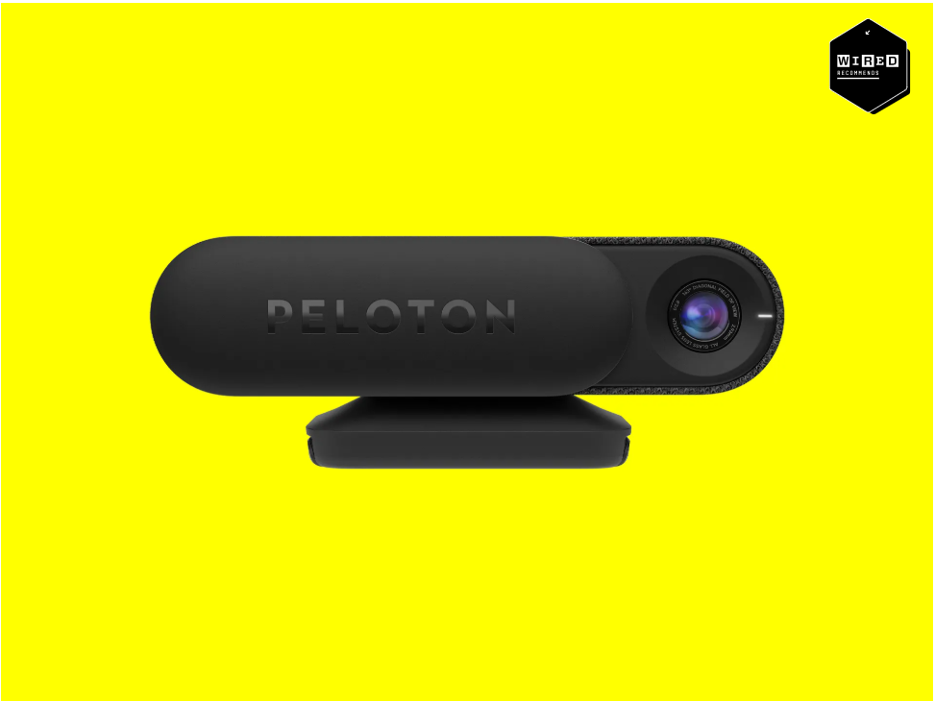

4. Tempo Studio
Website: https://tempo.fit/
Pricing: Paid (Hardware + Subscription)
Platform: Dedicated Hardware
Target Users: Home Fitness Users
Summary
Tempo Studio is an AI-powered smart home gym system that combines computer vision with 3D motion tracking to analyze users' movements, count repetitions, and improve exercise technique through real-time feedback.
Key Features
- 3D motion tracking
- AI-powered exercise recognition
- Automatic repetition counting
- Real-time form correction
- Range of motion analysis
- Personalized workout plans
- Performance analytics
- Smart weight integration
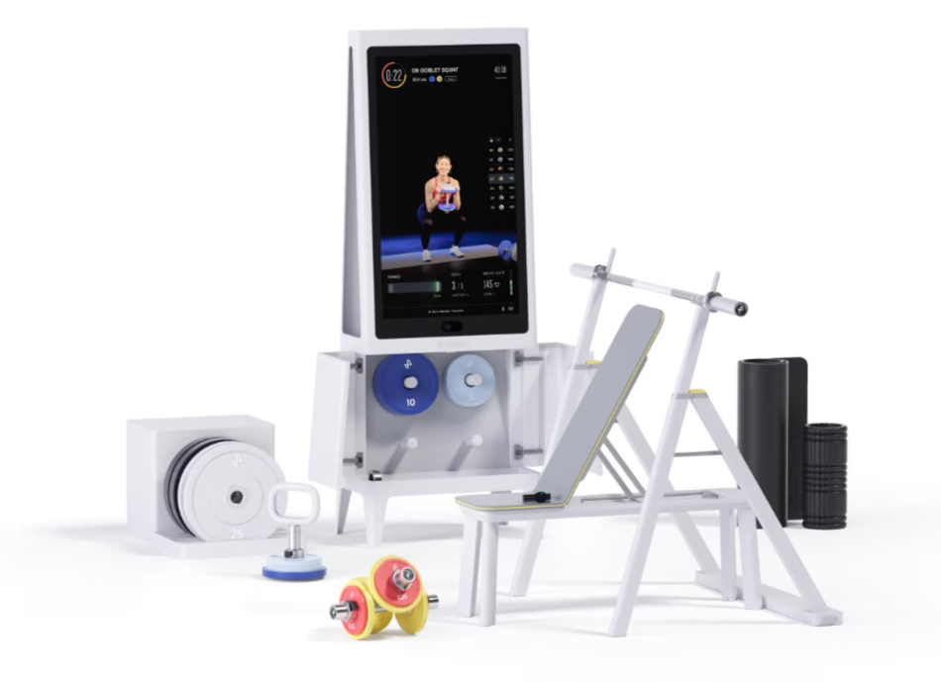

5. Gymetrics
Website: https://gymetrics.in/
Pricing: Paid (Enterprise Solution)
Platform: Web Dashboard + CCTV System
Target Users: Gym Owners, Fitness Centers
Summary
Gymetrics is an AI-powered gym analytics platform that utilizes existing CCTV cameras to monitor gym activities and provide operational insights. It focuses on improving gym management by analyzing occupancy, equipment utilization, and member behavior using computer vision.
Key Features
- AI-powered CCTV monitoring
- Real-time occupancy analysis
- Equipment usage tracking
- Heatmaps and activity analytics
- Gym management dashboard
- Operational insights for gym owners
- Uses existing surveillance cameras
- No wearable devices required
- Business intelligence and reporting

6. Exersight
Website: https://exersight.com/
Pricing: Paid
Platform: Web
Target Users: Gyms, Rehabilitation Centers, Fitness Professionals
Summary
Exersight is an AI-driven fitness monitoring platform that uses computer vision to analyze workout sessions through standard cameras. It automatically recognizes exercises, counts repetitions, evaluates form, and provides real-time feedback without requiring wearable sensors.
Key Features
- AI-based exercise recognition
- Automatic repetition counting
- Pose estimation
- Motion tracking
- Form and posture analysis
- Performance evaluation
- Camera-based workout monitoring
- Real-time feedback
- No wearable devices required

7. Exer AI
Website: https://exer.ai/
Pricing: Paid (Enterprise / Commercial)
Platform: Web
Target Users: Rehabilitation Centers, Healthcare Providers, Fitness Organizations
Summary
Exer AI is a computer vision platform that enables AI-powered movement analysis for fitness and rehabilitation. It monitors users during exercise sessions, recognizes movements, evaluates exercise quality, and delivers real-time performance feedback using standard cameras.
Key Features
- AI-powered pose estimation
- Exercise recognition
- Motion tracking
- Performance evaluation
- Real-time movement analysis
- Form correction
- Rehabilitation support
- Camera-based exercise monitoring
- No wearable devices required
- Clinical and rehabilitation applications

